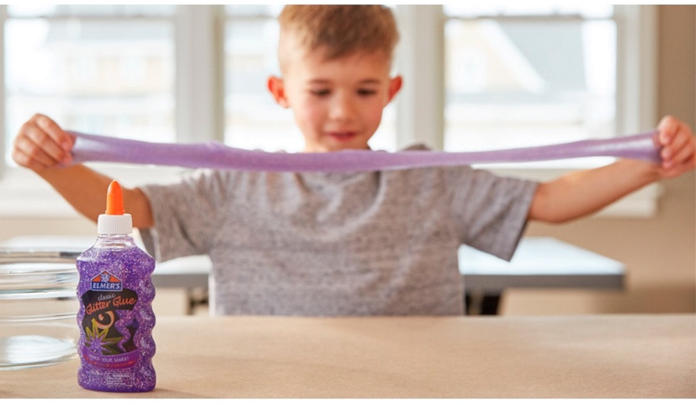
Glitter Slime Recipe
Create some sparkly slime using a few common household ingredients. It's super easy and kid friendly!

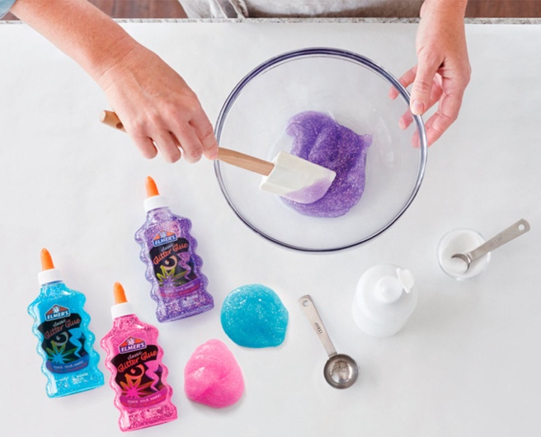
supplies needed
- 1/2 tbsp of baking soda
- 1¼ tbsp of contact lens solution
- 6 fl oz Elmer’s Glitter Glue

instructions
- Pour out the entire contents of a 6 oz of Elmer’s Glitter Glue into a bowl.
- Add ½ tbsp of baking soda and mix thoroughly.
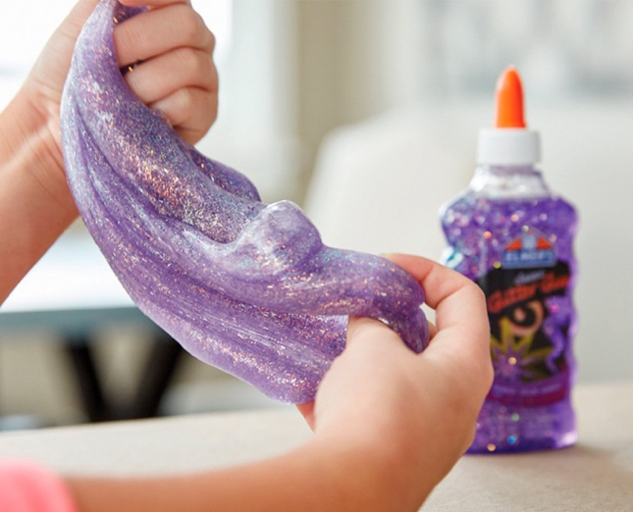
- Add 1¼ tbsp of contact lens solution.
- Mix until mixture gets harder to mix and slime begins to form.
- Take the slime out and begin kneading with both of your hands.
- If needed, add ¼ tbsp of contact lens solution to make the slime less sticky.

*Recipe from https://www.elmers.com/on/demandware.store/Sites-elmers-Site/default/Content-Show?cid=glitter-slime-recipe

